Assignment: Computer Networking
Wire Shark

Roll No: BSDSF22A025
Name: Lubaba Khalid

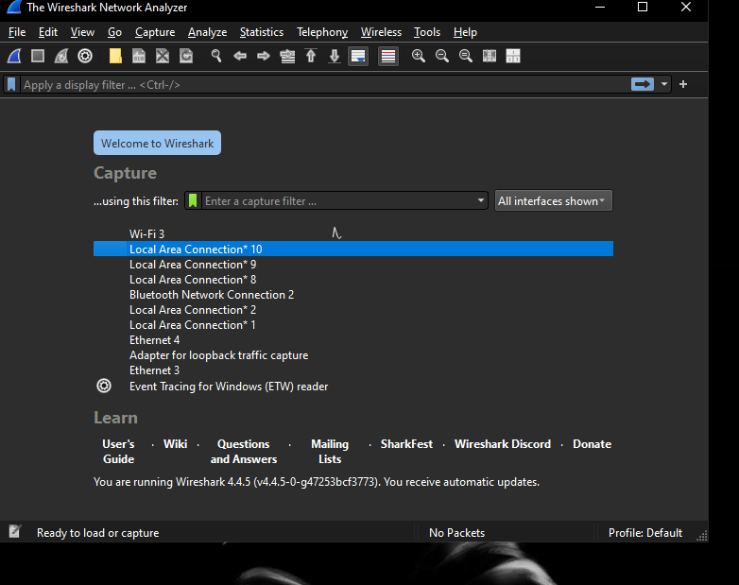
Selecting interface:
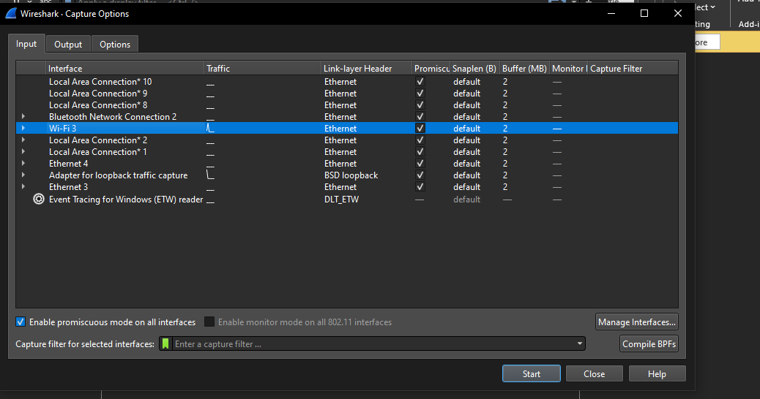

Capturing all Packets:
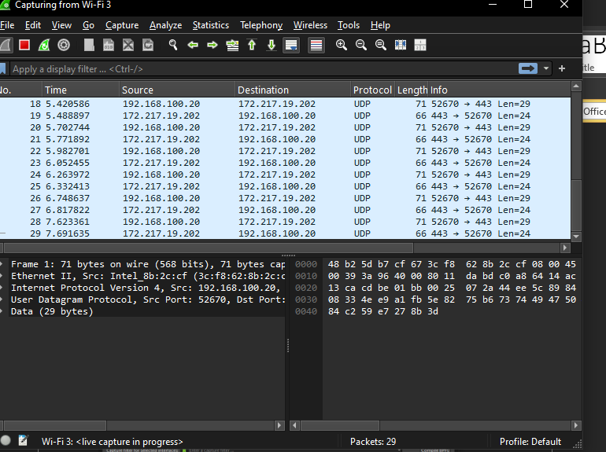
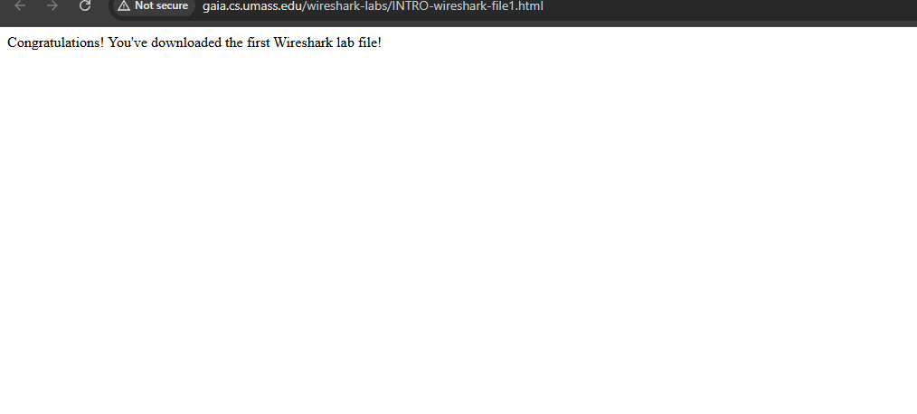

Capturing http Packets:
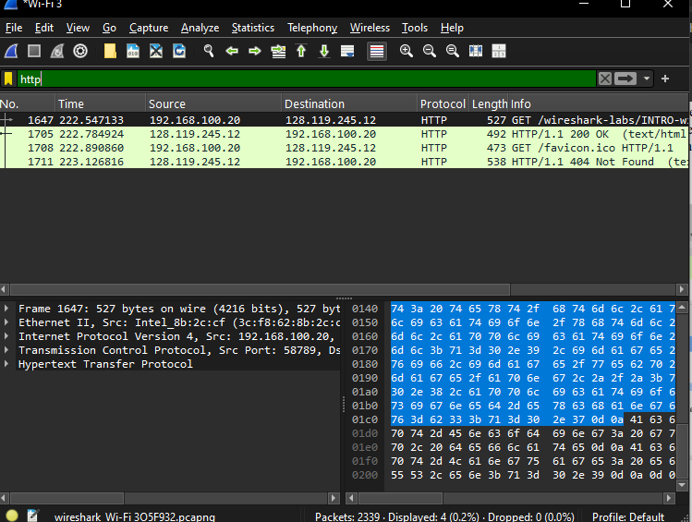
Q1: Which of the following protocols are shown as appearing (i.e., are listed in the Wireshark “protocol” column) in your trace file: TCP, QUIC, HTTP, DNS, UDP, TLSv1.2?
A: All the listed protocols are shown in the protocol columns

Q2: How long did it take from when the HTTP GET message was sent until the HTTP OK reply was received? (By default, the value of the Time column in the packet-listing window is the amount of time, in seconds, since Wireshark tracing began. (If you want to display the Time field in time-of-day format, select the Wireshark View pull down menu, then select Time Display Format, then select Time-of-day.)
A: 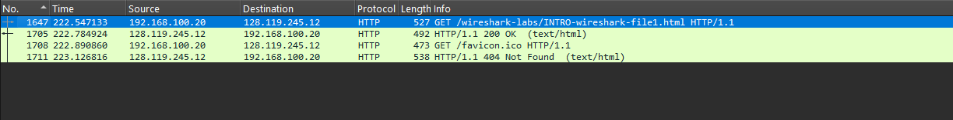

Q3: What is the Internet address of the gaia.cs.umass.edu (also known as www-net.cs.umass.edu)? What is the Internet address of your computer or (if you are using the trace file) the computer that sent the HTTP GET message?
A:
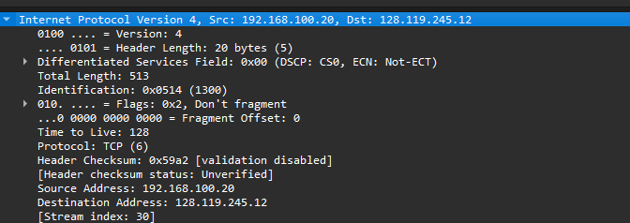

Q4. Expand the information on the HTTP message in the Wireshark “Details of selected packet” window (see
Figure 3 above) so you can see the fields in the HTTP GET request message. What type of Web browserissued the HTTP request? The answer is shown at the right end of the information following the “User-
Agent:” field in the expanded HTTP message display. [This field value in the HTTP message is how aweb server learns what type of browser you are using.]
• Firefox, Safari, Microsoft Internet Edge, Other

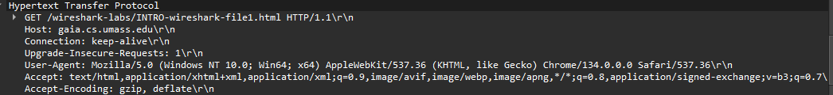
A: Check the User Agent

Q:5 Expand the information on the Transmission Control Protocol for this packet in the Wireshark “Details ofselected packet” window (see Figure 3 in the lab writeup) so you can see the fields in the TCP segmentcarrying the HTTP message. What is the destination port number (the number following “Dest Port:” forthe TCP segment containing the HTTP request) to which this HTTP request is being sent?
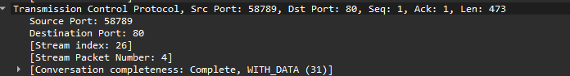
A: Check the Source and Destination Ports

